E-COMMERCE ORDER MANAGEMENT DATABASE SYSTEM

WEEK 2: PRODUCT AND CATEGORY MANAGEMENT SYSTEM

SAMPLE PRODUCT DATA

1. Category Records
The Category table contains the category details used to organize products in the E-Commerce Order Management Database System. Five categories are included for managing different types of products.
S.No | Category_ID | Category_Name | Description
1 | 1 | Mobile Accessories | Accessories for mobile phones
2 | 2 | Footwear | Different types of footwear
3 | 3 | Stationery | School and office stationery items
4 | 4 | Kitchen Items | Useful products for kitchen
5 | 5 | Beauty Products | Personal care and beauty products

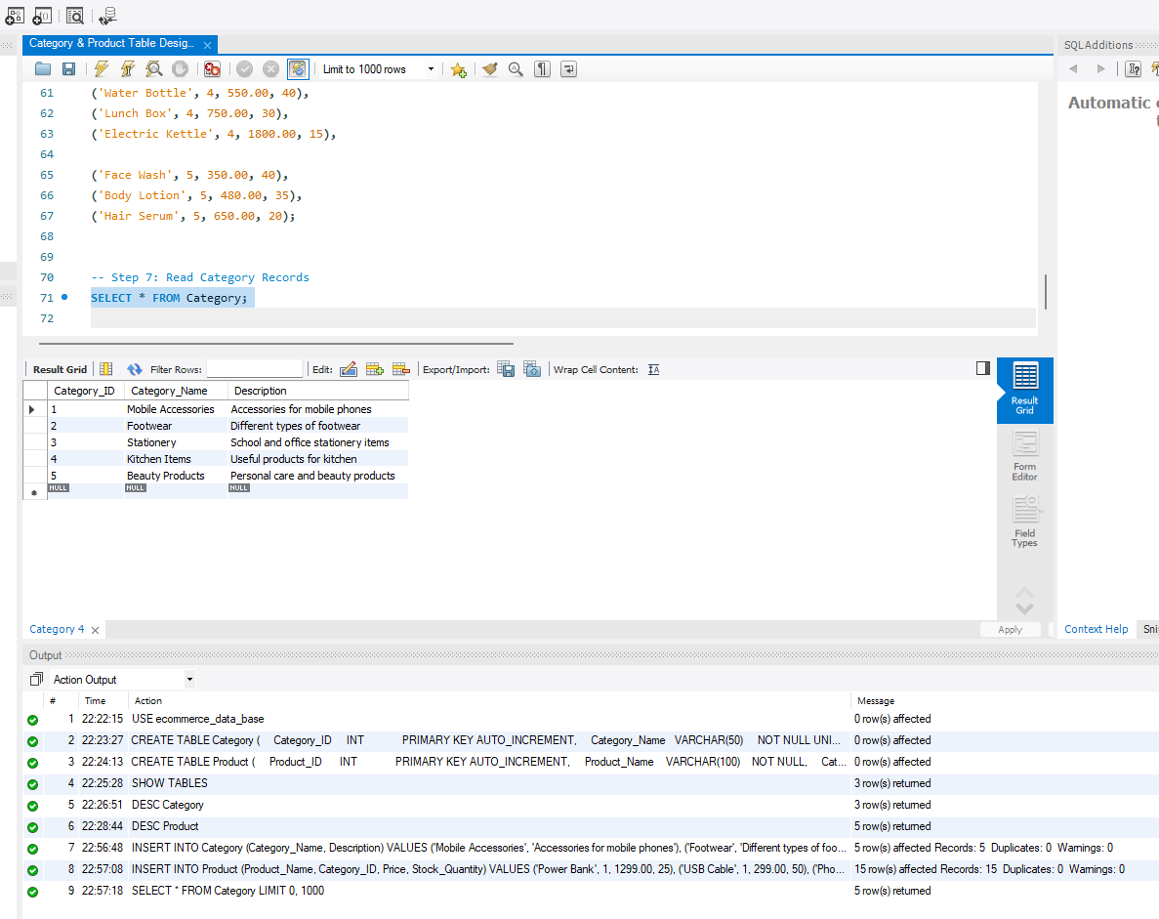

2. Product Records
The Product table contains sample product information along with the category to which each product belongs. The records include the product name, category ID, price, and available stock quantity.
S.No | Product_ID | Product_Name | Category_ID | Price | Stock_Quantity
1 | 1 | Power Bank | 1 | 1299.00 | 25
2 | 2 | USB Cable | 1 | 299.00 | 50
3 | 3 | Phone Stand | 1 | 450.00 | 35
4 | 4 | Sports Shoes | 2 | 2200.00 | 30
5 | 5 | Sandals | 2 | 850.00 | 45
6 | 6 | Slippers | 2 | 450.00 | 55
7 | 7 | Notebook | 3 | 120.00 | 80
8 | 8 | Pen Set | 3 | 180.00 | 60
9 | 9 | School Bag | 3 | 950.00 | 25
10 | 10 | Water Bottle | 4 | 550.00 | 40
11 | 11 | Lunch Box | 4 | 750.00 | 30
12 | 12 | Electric Kettle | 4 | 1800.00 | 15
13 | 13 | Face Wash | 5 | 350.00 | 40
14 | 14 | Body Lotion | 5 | 480.00 | 35
15 | 15 | Hair Serum | 5 | 650.00 | 20

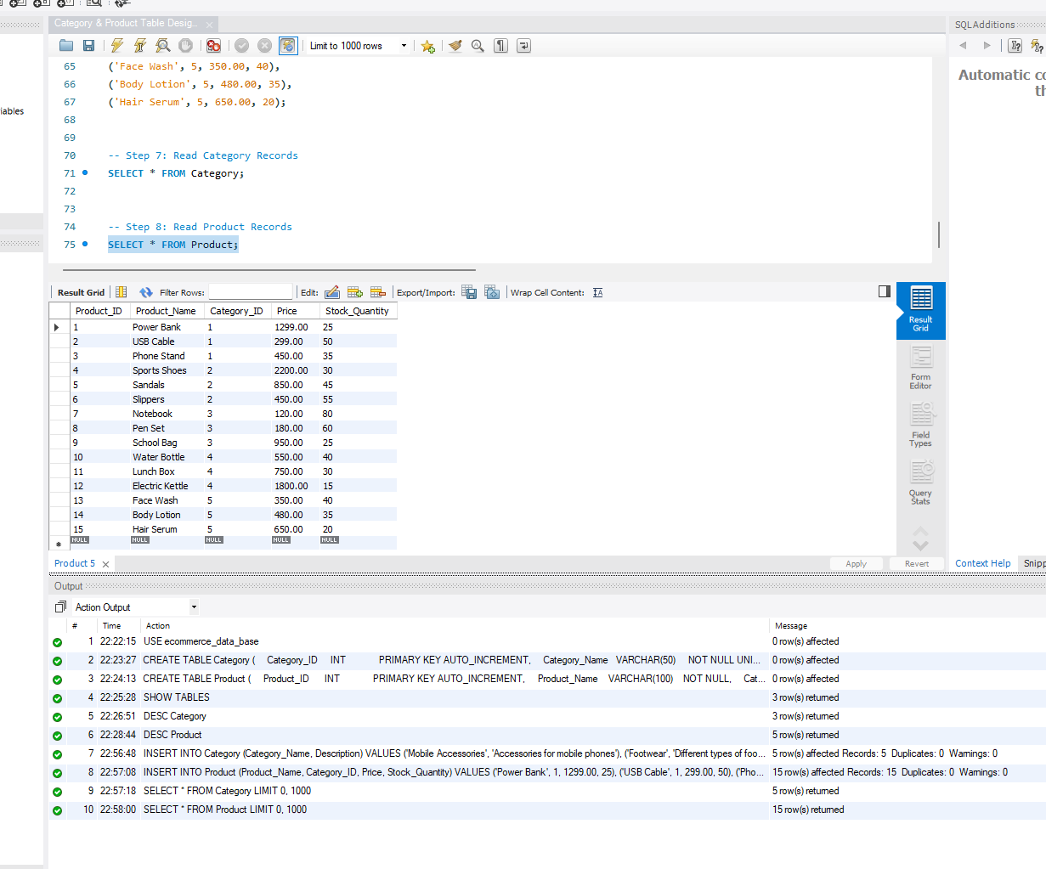

3. Additional Product Records
Two additional products are added to each category so that every category contains five products. These records are used for category-wise product analysis.
S.No | Product_Name | Category_ID | Price | Stock_Quantity
1 | Car Charger | 1 | 599.00 | 30
2 | Bluetooth Speaker | 1 | 1499.00 | 20
3 | Canvas Shoes | 2 | 1600.00 | 25
4 | Flip Flops | 2 | 350.00 | 50
5 | Marker Set | 3 | 250.00 | 45
6 | Drawing Book | 3 | 150.00 | 60
7 | Frying Pan | 4 | 900.00 | 25
8 | Spice Rack | 4 | 650.00 | 30
9 | Sunscreen | 5 | 550.00 | 35
10 | Lip Balm | 5 | 180.00 | 50

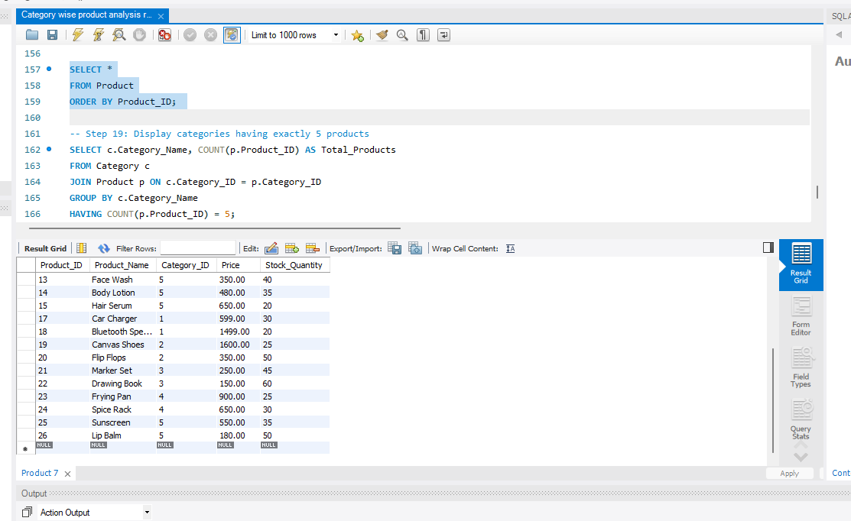

4. Final Product Count
After adding the additional records, each category contains five products.

Category_Name | Number of Products
Mobile Accessories | 5
Footwear | 5
Stationery | 5
Kitchen Items | 5
Beauty Products | 5

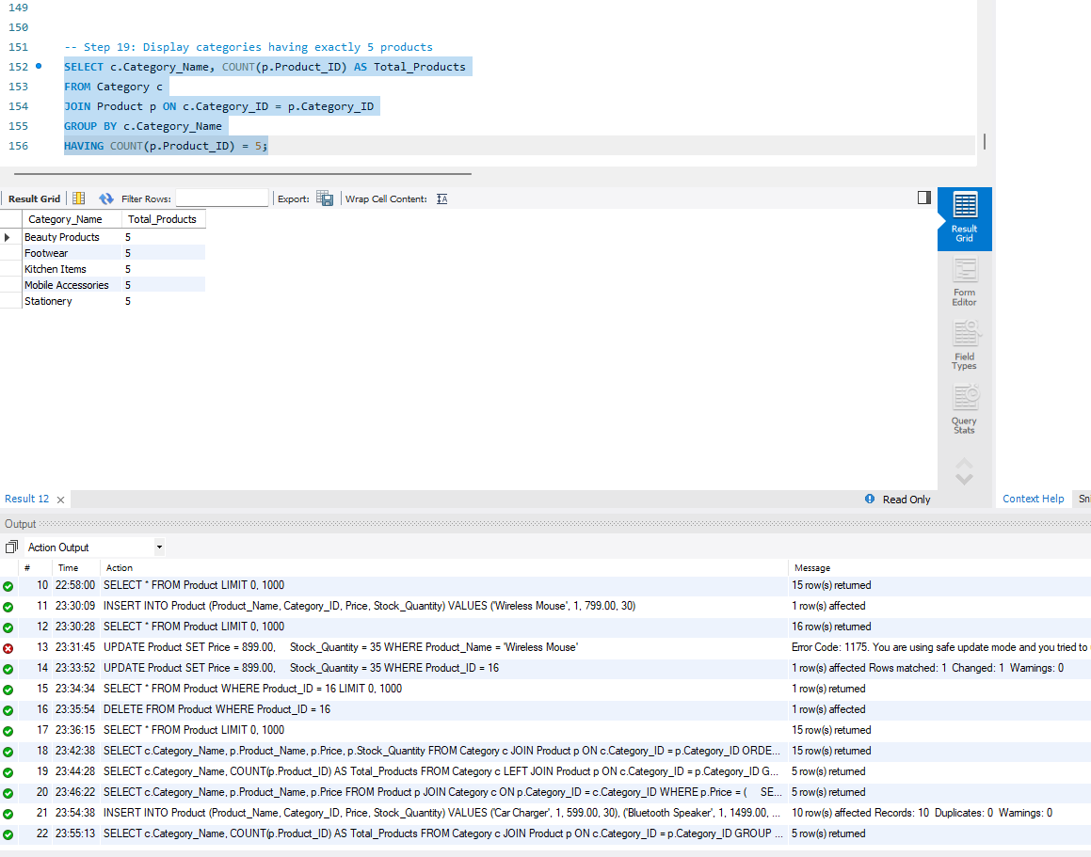

5. Conclusion
The sample data provides the required category and product records for the Product and Category Management System. The records include product details, prices, and stock quantities. The data is also suitable for performing CRUD operations and category-wise product analysis.

